Austin Smothers

Professor Bustamante

CSC 137

July 3, 2019

Project 2

State Diagram:

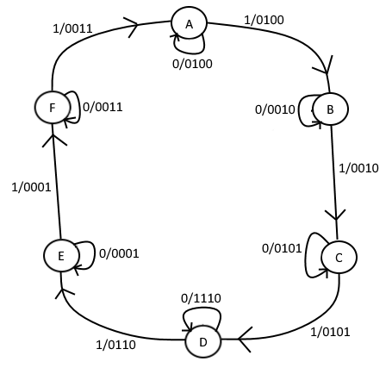

State Assignment:

{ A = 101 D = 110 }

{ B = 011 E = 100 }

{ C = 010 F = 001 }

State Table:

|  |  |  |  |  |  |  |  |  |  |  |
| --- | --- | --- | --- | --- | --- | --- | --- | --- | --- | --- |
| q3 | q2 | q1 | R | O3 | O2 | O1 | B | q3+ | q2+ | q1+ |
| 0 | 0 | 0 | 0 | 0 | 0 | 0 | 0 | 0 | 0 | 0 |
| 0 | 0 | 0 | 1 | 0 | 0 | 0 | 0 | 1 | 0 | 1 |
| 1 | 0 | 1 | 0 | 1 | 0 | 0 | 0 | 1 | 0 | 1 |
| 1 | 0 | 1 | 1 | 1 | 0 | 0 | 0 | 0 | 1 | 1 |
| 0 | 1 | 1 | 0 | 0 | 1 | 0 | 0 | 0 | 1 | 1 |
| 0 | 1 | 1 | 1 | 0 | 1 | 0 | 0 | 0 | 1 | 0 |
| 0 | 1 | 0 | 0 | 1 | 0 | 1 | 0 | 0 | 1 | 0 |
| 0 | 1 | 0 | 1 | 1 | 0 | 1 | 0 | 1 | 1 | 0 |
| 1 | 1 | 0 | 0 | 1 | 1 | 0 | 1 | 1 | 1 | 0 |
| 1 | 1 | 0 | 1 | 1 | 1 | 0 | 0 | 1 | 0 | 0 |
| 1 | 0 | 0 | 0 | 0 | 0 | 1 | 0 | 1 | 0 | 0 |
| 1 | 0 | 0 | 1 | 0 | 0 | 1 | 0 | 0 | 0 | 1 |
| 0 | 0 | 1 | 0 | 0 | 1 | 1 | 0 | 0 | 0 | 1 |
| 0 | 0 | 1 | 1 | 0 | 1 | 1 | 0 | 1 | 0 | 1 |

K-Map Minimization:

O3:

|  |  |  |  |  |  |
| --- | --- | --- | --- | --- | --- |
| q3q2 | q1R | 00 | 01 | 11 | 10 |
| 00 | | 0 | 0 | 0 | 0 |
| 01 | | 1 | 1 | 0 | 0 |
| 11 | | 1 | 1 | d | d |
| 10 | | 0 | 0 | 1 | 1 |

O3 = (q2) + (q3q1)

O2:

|  |  |  |  |  |  |
| --- | --- | --- | --- | --- | --- |
| q3q2 | q1R | 00 | 01 | 11 | 10 |
| 00 | | 0 | 0 | 1 | 1 |
| 01 | | 0 | 0 | 1 | 1 |
| 11 | | 1 | 1 | d | d |
| 10 | | 0 | 0 | 0 | 0 |

O2 = (q1) + (q3q2)

O1:

|  |  |  |  |  |  |
| --- | --- | --- | --- | --- | --- |
| q3q2 | q1R | 00 | 01 | 11 | 10 |
| 00 | | 0 | 0 | 1 | 1 |
| 01 | | 1 | 1 | 0 | 0 |
| 11 | | 0 | 0 | d | d |
| 10 | | 1 | 1 | 0 | 0 |

O1 = (q2) + (q1) + (q3)

B (output_logic):

|  |  |  |  |  |  |
| --- | --- | --- | --- | --- | --- |
| q3q2 | q1R | 00 | 01 | 11 | 10 |
| 00 | | 0 | 0 | 0 | 0 |
| 01 | | 0 | 0 | 0 | 0 |
| 11 | | 1 | 0 | d | d |
| 10 | | 0 | 0 | 0 | 0 |

B = (q3q2)

q3+:

|  |  |  |  |  |  |
| --- | --- | --- | --- | --- | --- |
| q3q2 | q1R | 00 | 01 | 11 | 10 |
| 00 | | 0 | 1 | 1 | 0 |
| 01 | | 0 | 1 | 0 | 0 |
| 11 | | 1 | 1 | d | d |
| 10 | | 1 | 0 | 0 | 1 |

s3 = (q2R) + () + (q­3q2) + (q3)

q2+:

|  |  |  |  |  |  |
| --- | --- | --- | --- | --- | --- |
| q3q2 | q1R | 00 | 01 | 11 | 10 |
| 00 | | 0 | 0 | 0 | 0 |
| 01 | | 1 | 1 | 1 | 1 |
| 11 | | 1 | 0 | d | d |
| 10 | | 0 | 0 | 1 | 0 |

s2 = (q2) + (q2) + (q3q1R)

q1+:

|  |  |  |  |  |  |
| --- | --- | --- | --- | --- | --- |
| q3q2 | q1R | 00 | 01 | 11 | 10 |
| 00 | | 0 | 1 | 1 | 1 |
| 01 | | 0 | 0 | 0 | 1 |
| 11 | | 0 | 0 | d | d |
| 10 | | 0 | 1 | 1 | 1 |

s1 = (R) + (q1)

Circuit Diagram:

